EV3 Software Setup for Personal Computer

These instructions will help you setup MATLAB to work with the LEGO Mindstorms EV3 System on your personal computer. ASU computers in BYENG 222 and BYENG 209 already have all necessary setup completed. These instructions are designed for Windows PC, but the general steps should work for MacOS as well with some minor detail changes.

Instructors will not provide technical support for Personal Computers or software installed on personal computers. The tutorials require that your computer has built-in Bluetooth capabilities.

# Download and Install EV3 and MATLAB

First download and install the following software:

[Lego Mindstorms EV3](https://www.lego.com/en-us/mindstorms/downloads/download-software)

Current Version of MATLAB

* Login to MyASU
* Login to the MathWorks site using your ASURITE login: <http://links.asu.edu/matlab>
* Enter your Mathworks account information to bind to your ASURITE login. If you do not have an account you will have to create one. Please create your account using your ASURITE email address and have a different password.
* Click the download button for the current release.
* Click the installer button to download the installer.
* On the Mathworks Website, click on your name in the upper right corner, then select "Associate License".
* Associate a student license key from the [MATLAB License Page.](https://dev-myapps2.ws.asu.edu/content/matlab-site-license)

**Install and Activate**

* Locate the installer you downloaded in a file browser. It should be located in the default download location, unless you specified another location.
  + Windows: matlab_<release>_win64.exe
  + Mac OS X: matlab_<release>_maci64.zip Where <release> represents the release number.
* Start the installer:
  + Windows: Double-click the installer file you downloaded in the previous step. The Windows Self-Extractor runs, and then the installer starts.
  + Mac OS X: Double-click the installer file you downloaded in the previous step. This action extracts the files and creates another folder called matlab_<release>_maci64, where <release> represents the release number. Inside this folder, double-click InstallForMacOSX to start the installer.
* In the MathWorks installer, select Log in with a MathWorks Account and follow the online instructions.
* When prompted to do so, select the license you want to use.
* NOTE: Users should not select the Concurrent option.
* Select the products you want to download and install.
* After downloading and installing your products, keep the Activate MATLAB checkbox selected and click Next.
* When asked to provide a user name, verify that the displayed user name is correct. Continue with the process until activation is complete.

# Download and Install EV3 MATLAB Toolbox

On your course blackboard site, download the EV3_Toolbox.zip file.

Extract the file to a folder using 7zip (or other decompression program), then copy the resulting EV3 folder into the MATLAB toolbox folder. This folder is likely located at:

**C:\Program Files\MATLAB\R2017b\toolbox**

# 3. Set EV3 Toolbox Path in MATLAB

Start the MATLAB program, then click the "Set Path" button

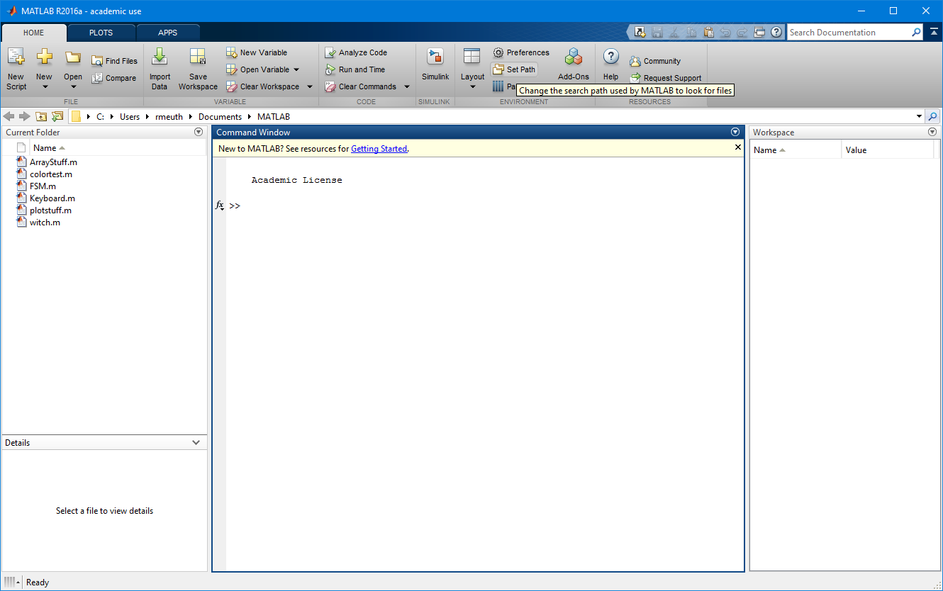

**Click "Add Folder"** then navigate to and select the EV3 Folder you copied into the MATLAB toolbox folder.

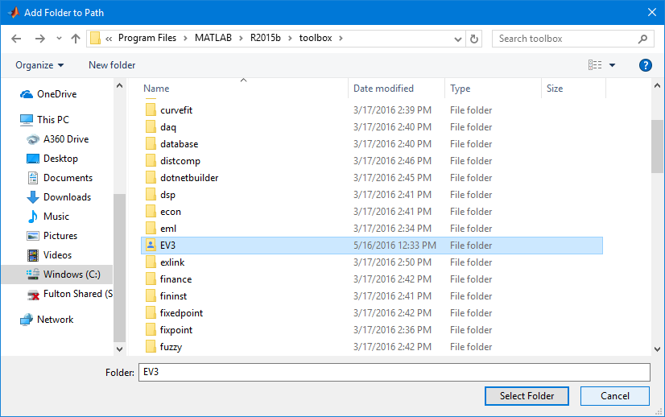

**Click "Select Folder"**

**Click "Save"**

**Click "Close"**

Done! You should be able to follow the MATLAB skills module instructions and connect to the EV3 Brick.